Acting in a Nutshell

- Concentrate on your part within the context of the “Big Picture.” In other words, don’t lose sight of the forest for the trees.

- Play to the audience. This means you should turn out toward the audience slightly, whenever you are talking to someone on stage. (Forcing another actor to turn his back to the audience is called ‘upstaging.’)

- STAY IN CHARACTER the whole time you are in front of the audience. If you aren’t speaking or otherwise in the spotlight, you should be reacting in character to what’s going on, on stage. COROLLARY: stay in character no matter what happens! (planned or unplanned) (This skill is also referred to as reacting or pointing.)

- Act with your whole body.

- We all intuitively feel and communicate in the drama of everyday life. And we see others model this for us – either on TV, in movies, or in real life. The general rule on stage is to EXAGGERATE, MAGNIFY, AMPLIFY your gestures, expressions, and your voice, so that the person sitting at the farthest point from you can hear and see everything. Turn up your VOLUME, turn up your ENERGY! Another aspect of this is to ENUNCIATE clearly. (All of this is called projecting.)

- No dead spots (time lapses) between speaking parts. Keep the dialog moving. (This is called picking up your lines.)

- Have FUN with your part. Play, improvise!

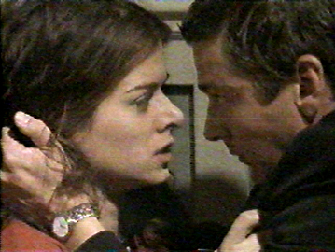
photograph is property of abc and warner bros.

