To Think About…

Performing in front of a television or movie camera is a little different than performing on stage, but the skills still apply. In some situations, especially in early TV, actors performed simultaneously in front of the camera and a live audience.

How is performing in front of a camera different from performing on a stage?

The next time you watch a television comedy or drama, see if you can spot instances of these fundamental acting skills – upstaging, projecting, acting with your whole body, picking up your lines, staying in character, having fun with your part.

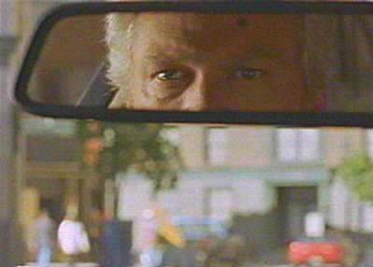
photograph belongs to ABC and Warner Bros.

